Education Authority:
Schools:
- It lists all the schools in tabular format.
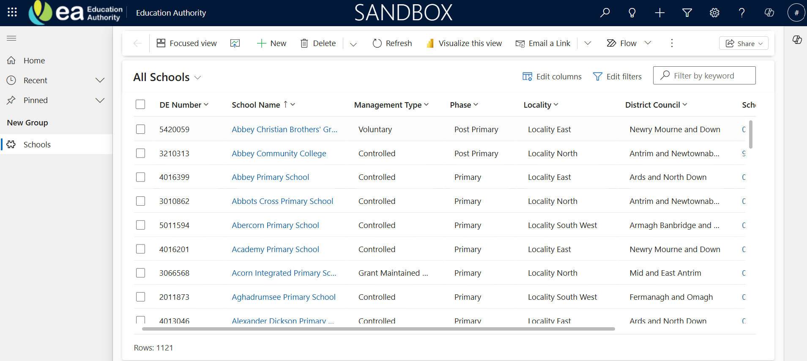
General Tab:
- When Clicked on any School Name, it will navigate the General tab showing all the general details. Table name is School.
- It Consists of 4 sections. Two are 2 -column section and the others are 1 – column section with sub grid.

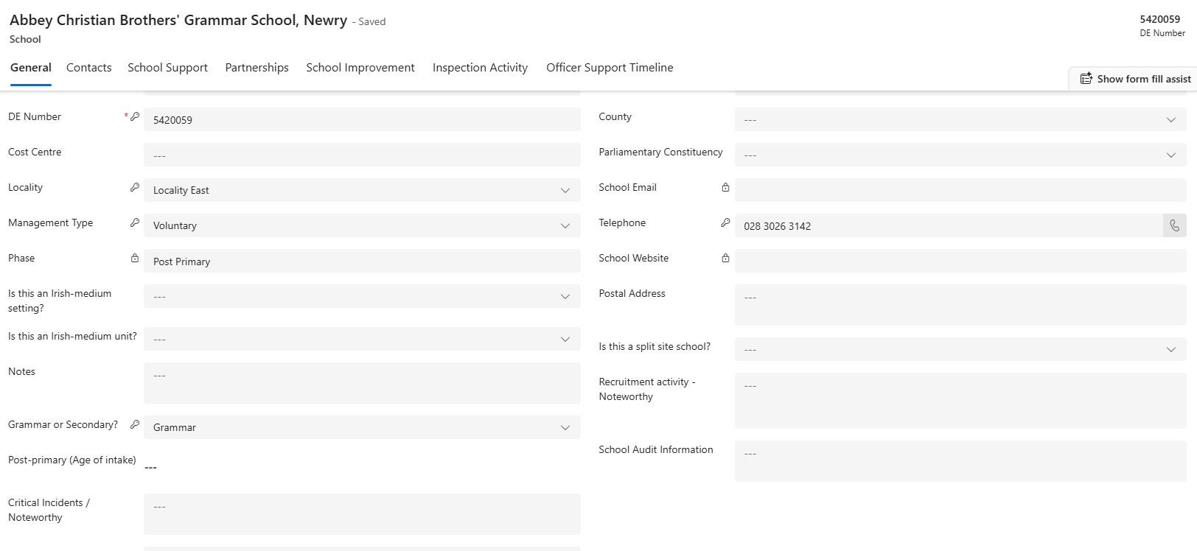

- 1st section is General details as captured in the above screenshot. The fields and the data type are as follows
- School Name – Look up from school table.
- DE Number - Number field
- Cost Centre - Number field
- Locality - Single choice field with 3 options.
- Management Type - Single choice field with 6 options
- Phase – Text field.
- Is this an Irish-medium setting? - Choice with yes/no option
- Is this an Irish-medium unit? - Choice with yes/no option
- Notes – Multi line text area
- Grammar or Secondary? - Single choice field with 2 options
- Post-primary (Age of intake) - Multi Select choice field with 4 options
- Critical Incidents / Noteworthy - Multi line text area
- Ministerial Visits / Other - Multi line text area
- District Council - Single choice field with 11 options
- County - Single choice field with 6 options
- Parliamentary Constituency - Single choice field with 18 options
- School Email – Email field
- Telephone – Phone no field
- School Website – URL field
- Postal Address - Multi line text area
- Is this a split site school? - Choice with yes/no option
- Recruitment activity – Noteworthy - Multi line text area
- School Audit Information - Multi line text area

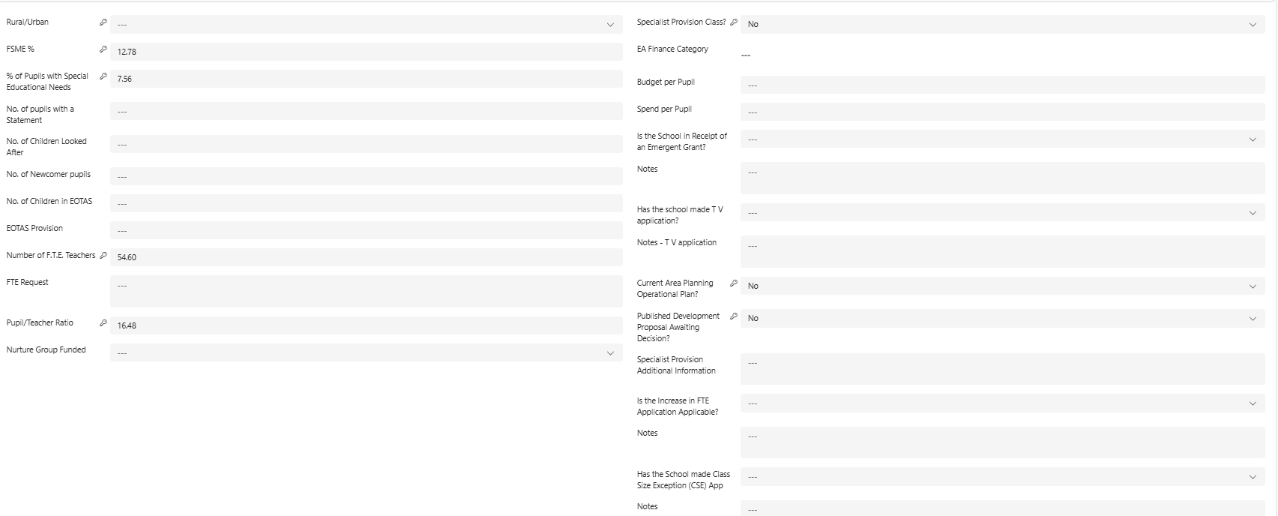

- 2nd Section is school details section as captured in the screenshot above. The fields and the data type are as follows
- Rural/Urban - Single choice field with 2 options
- FSME % - Integer field
- % of Pupils with Special Educational Needs - Integer field
- No. of pupils with a Statement - Number field
- No. of Children Looked After - Number field
- No. of Newcomer pupils - Number field
- No. of Children in EOTAS - Number field
- EOTAS Provision – Single line text
- Number of F.T.E. Teachers – Integer field
- FTE Request – Multi line text area
- Pupil/Teacher Ratio – Integer field
- Nurture Group Funded - Choice with yes/no option
- Specialist Provision Class? - Choice with yes/no option
- EA Finance Category - Multi Select choice field with 7 options
- Budget per Pupil – Number field
- Spend per Pupil - Number field
- Is the School in Receipt of an Emergent Grant? - Choice with yes/no option
- Notes - Multi line text area
- Has the school made T V application? - Choice with yes/no option
- Notes - T V application - Multi line text area
- Current Area Planning Operational Plan? - Choice with yes/no option
- Published Development Proposal Awaiting Decision? - Choice with yes/no option
- Specialist Provision Additional Information – Multi line text
- Is the Increase in FTE Application Applicable? - Choice with yes/no option
- Notes - Multi line text
- Has the School made Class Size Exception (CSE) App - Choice with yes/no option
- Notes - Multi line text

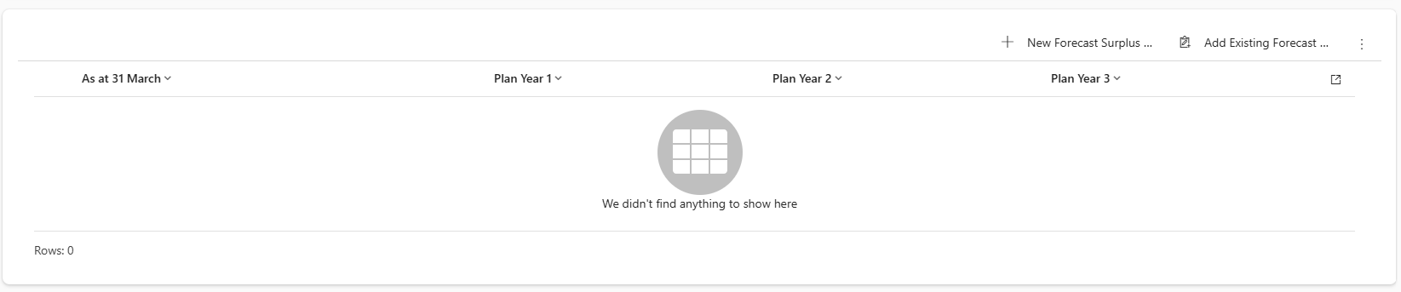
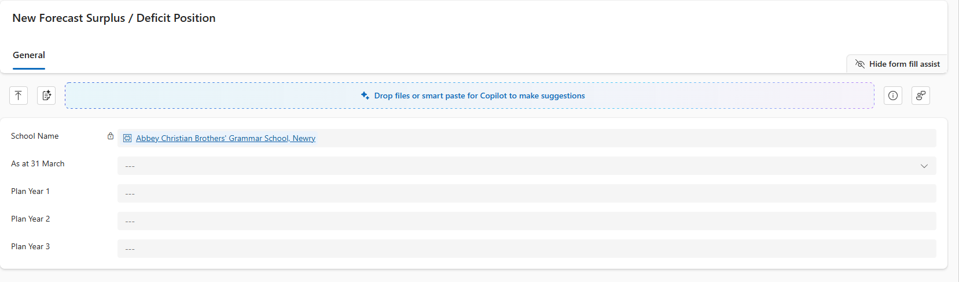

- 3rd section is 1 column section with sub grid. We have a form and view for displaying the data. The fields are as follows
- As at 31 March - Single choice option with 5 options
- Plan Year 1 - Number
- Plan Year 2 – Number
- Plan Year 3 – Number

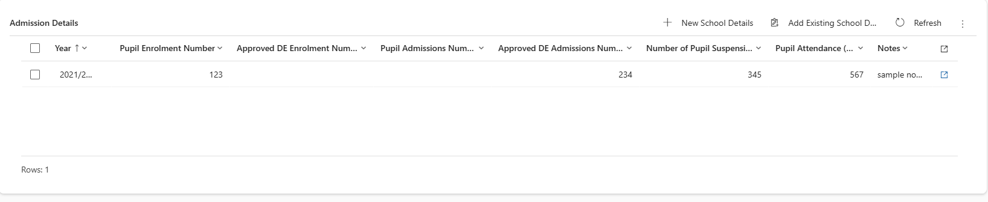
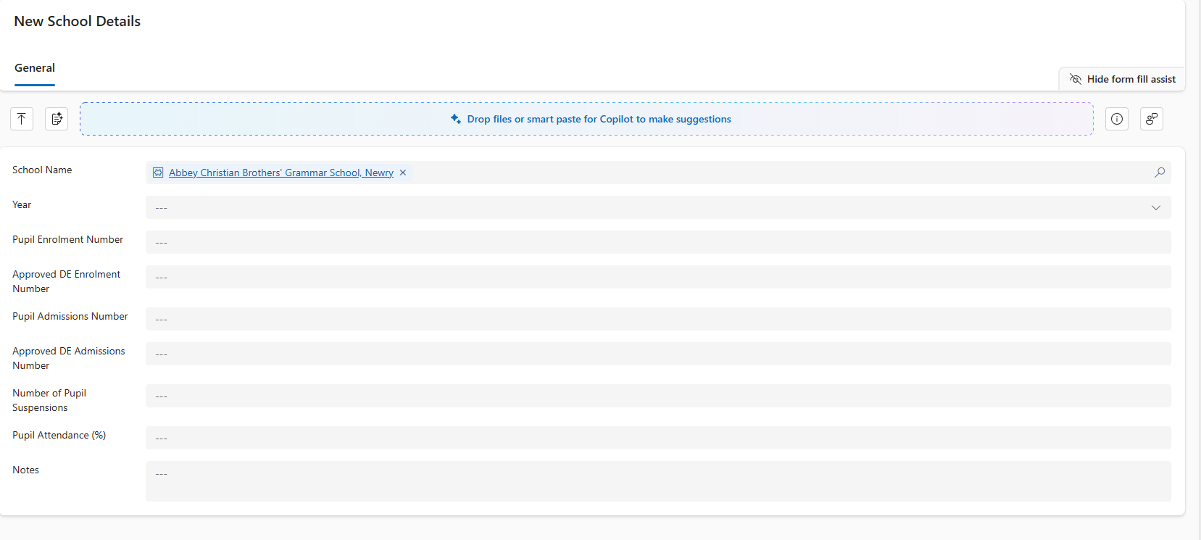
- 4th section is Admission details for which we have used sub grid. Form and view are used to display the data.
- School Name - Look up
- Year – Choice, which we have created and used across different tabs.
- Pupil Enrolment Number – Number
- Approved DE Enrolment Number – Number
- Pupil Admissions Number – Number
- Approved DE Admissions Number – Number
- Number of Pupil Suspensions - Number
- Number of Pupil Suspensions – Number
- Notes - Number

